Bank of America Fact Sheet

Quick Facts & Talking Points

- Total Assets 2019
  - $2.3 trillion

- Total Fossil Fuel Financing in 2019
  - $48 billion

- Total Fossil Fuel Financing Between 2016-2019
  - $157 billion
  - Between 2018-2019 Bank of America made the largest increase in annual fossil fuel financing out of all the major private banks, increasing by $13.1 billion.

Between 2016-2019 Bank of America financed:
Financing | Fossil Fuel Type | Rank out of Top 35 Fossil Fuel Financiers
$61.65 B | Fossil Fuel Expansion | 3rd
$2.4 B | Tar Sands | 10th
$859 M | Arctic oil & gas drilling | 11th
$14.9 B | Offshore oil & gas drilling | 4th
$30.2 B | Fracked oil & gas | 3rd
$4.1 B | Liquefied Natural Gas (LNG) | 7th
$426 M | Coal Mining | 18th
$4.3 B | Coal Power Stations | 8th

- Total Annualized Sustainable Finance Commitments
  - $27.2 billion

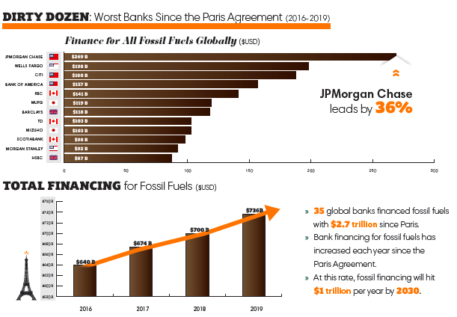

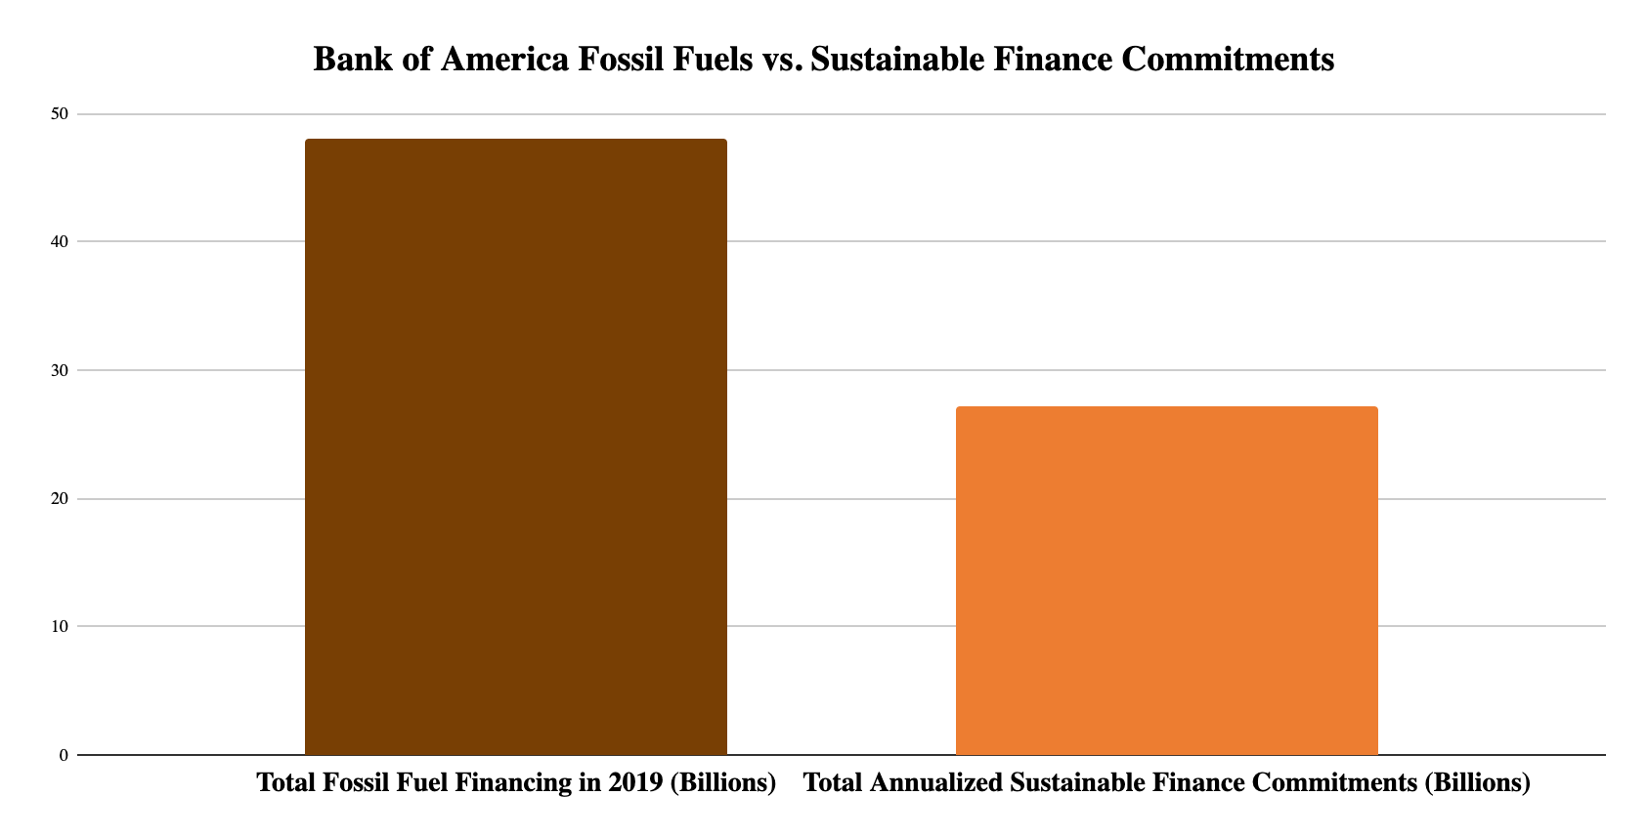

Rainforest Action Network designates policy scores based on a point system that assesses bank policies on ending financing for fossil fuel expansion and phasing out overall fossil fuel financing. Bank of America received only 6 out of 200 possible points, demonstrating one of the lowest scores for a major bank. For more detail into the scoring criteria, including for each fossil fuel subsector, visit the Banking on Climate Change 2020 report appendix. See below a fossil fuel policy score comparison of the major private US banks.

Bank | Total Fossil Fuel Policy Score (Out of 200)
Citi | 22
JPMorgan Chase | 19.5
Wells Fargo | 9
Bank of America | 6
Morgan Stanley | 21
Goldman Sachs | 21.5

Fossil Fuel Policies

Bank of America released its Environmental and Social Risk Policy Framework in October 2019 and since then in November 2020 has introduced one new formal policy shift.

Oil & Natural Gas
No prohibitive policies.

Coal
Bank of America will not finance the construction of new coal-fired power plants in developed countries without technologies to address their carbon emissions, and will only finance construction in developing countries in certain circumstances.

Arctic Region
Bank of America announced in November 2020 that it will not provide project financing for oil and gas exploration in the Arctic after facing opposition from environmentalists for not explicitly banning it. This decision makes Bank of America the final of the top 6 major US private banks to codify this policy and ban financing destructive activity in the National Wildlife Refuge.

Measure - Disclose - Reduce

In July 2020, Bank of America committed to the PCAF Standards, agreeing to disclose the greenhouse gas emissions associated with their portfolio of loans and investments.

In June 2017, JPM signed on to the Task Force on Climate Related Financial Disclosures, a set of consistent and coherent principles for voluntary climate-related financial risk disclosures that provide information to investors, lenders, insurers, and other stakeholders.

Recent Low-Carbon Announcements

- In January 2020 CEO Brian Moynihan said Bank of America would use the SDG rating system across its business, from credit assessments for its lending arm to portfolio construction for clients of the Merrill Lynch wealth management arm. Mr. Moynihan’s effort does not intend to create new metrics but to craft a rating system from work already done by groups such as the Sustainable Accounting Standards Board (SASB).

- Bank of America announced it will mobilize an additional $300 billion in capital by 2030 through its Environmental Business Initiative.

- In April 2020, Bank of America released its Task Force on Climate-related Financial Disclosures (TCFD) Report, reflecting its support for disclosure and transparency of climate-related business risks. The company’s TCFD Report articulates how it evaluates the impact of climate change on its business, manages those risks, and continues to enhance its understanding of how to measure and model climate-related risks and their potential significance.

- Bank of America established a Sustainable Markets Committee, co-chaired by Finucane and Bank of America Chief Operating Officer Tom Montag. Working with the International Business Council (IBC) of World Economic Forum (WEF) and the accounting firms Deloitte, EY, KPMG and PwC, Bank of America will develop a common core set of metrics and recommended disclosures that companies can use to help guide stakeholders in evaluating their progress on advancing Sustainable Development Goal (SDG) priorities. Bank of America CEO Brian Moynihan serves as chair of the IBC. The common core metrics will be used to measure and disclose meaningful and relevant aspects of environmental, social and governance (ESG) performance, including TCFD-aligned reporting on material climate risks and opportunities.

- Bank of America has issued five corporate green bonds raising a total of $6.35 billion for renewable energy projects between 2013-2019.

Read Bank of America’s Task Force on Climate-related Financial Disclosures (TCFD) Report here: https://about.bankofamerica.com/assets/pdf/task-force-climate-financial-disclosures-report.pdf

Read Bank of America’s Environmental and Social Risk Policy Framework 2019 here:
https://about.bankofamerica.com/assets/pdf/Environmental-and-Social-Risk-Policy-Framework.pdf

Website | bank-fwd.org
Email | info@bank-fwd.org

Read more here: https://www.ft.com/content/876f143a-36de-11ea-a6d3-9a26f8c3cba4?emailId=5ee9e83cdfb6ef0004d5f3b3&segmentId=a8cbd258-1d42-1845-7b82-00376a04c08f

