Citi Fact Sheet

Quick Facts & Talking Points

- Citi is #3 on the Dirty Dozen list

- Total Assets 2019
  - $1.9 trillion

- Total Fossil Fuel Financing in 2019
  - $52.4 billion

- Total Fossil Fuel Financing Between 2016-2019
  - $188 billion

Between 2016-2019 Citi financed:
Financing | Fossil Fuel Type | Rank out of Top 35 Fossil Fuel Financiers
$71.68 B | Fossil Fuel Expansion | 2nd
$2.7 B | Tar Sands | 8th
$1.4 B | Arctic oil & gas drilling | 2nd
$18 B | Offshore oil & gas drilling | 2nd
$27.9 B | Fracked oil & gas | 4th
$4.7 B | Liquefied Natural Gas (LNG) | 5th
$1.4 B | Coal Mining | 8th
$6.7 B | Coal Power Stations | 5th

- Total Annualized Sustainable Finance Commitments
  - $10 billion

Leadership

- Citi has named Jane Fraser as its new chief executive officer. She is set to become the first woman ever to lead a mega Wall Street bank, succeeding Michael Corbat when he retires in February 2021 following eight years at the helm of the firm. Fraser has worked at the bank for 16 years and currently serves as the president, leading the global consumer banking side of the business.

- Under the leadership of CEO Michael Corbat, Citi was the first US bank to sign on to UN Principles for Responsible Banking and signed the Business Roundtable's Statement on the Purpose of a Corporation.

Major Fossil Fuel Industry Commitments

- Citi is the #1 North American funder of coal power.

- Citi is #2 in the world in financing for oil, gas, and coal companies expanding fossil fuels.

- Citi is #2 in the world for funding offshore oil & gas and Arctic oil & gas.

- On April 2, 2020, Citi, along with JPMorgan Chase, led the underwriting of a USD $1.25 billion bond issuance for TC Energy, the company moving forward with the controversial Keystone XL tar sands oil pipeline. NASA scientist James Hansen explained that draining those tar sands deposits would be “game over” for the climate system.

Fossil Fuel Policies Score

Rainforest Action Network (RAN) designates policy scores based on a point system that assesses bank policies on ending financing for fossil fuel expansion and phasing out overall fossil fuel financing. Citi received only 22 out of 200 possible points, demonstrating a very low score. For more detail into the scoring criteria, including for each fossil fuel subsector, visit the Banking on Climate Change 2020 report appendix as well as this RAN press release. See below a fossil fuel policy score comparison of the major private US banks.

Bank | Total Fossil Fuel Policy Score (Out of 200)
Citi | 22
JPMorgan Chase | 19.5
Wells Fargo | 9
Bank of America | 6
Morgan Stanley | 21
Goldman Sachs | 21.5

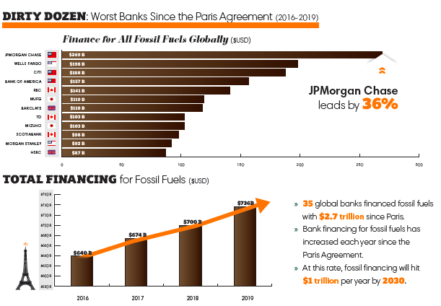

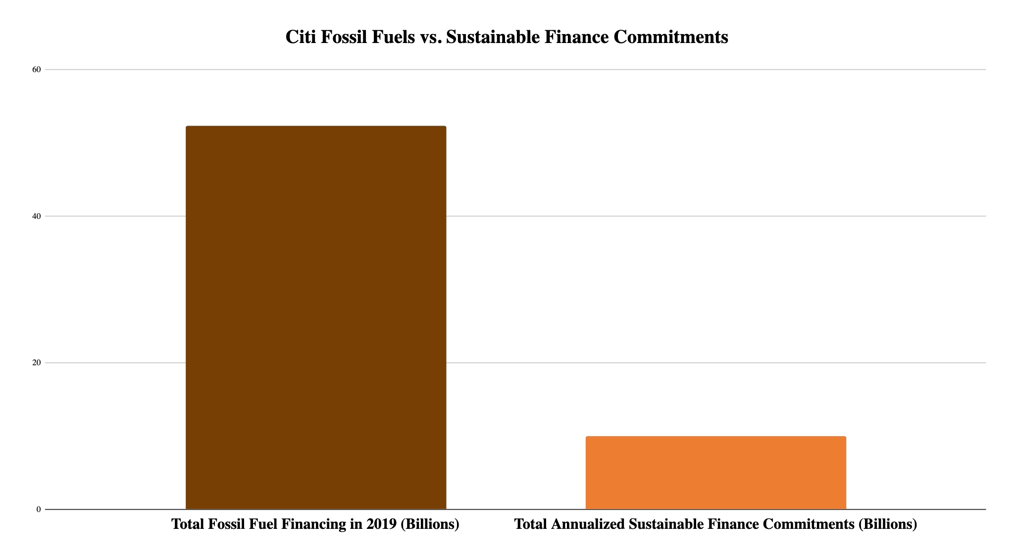
Fossil Fuel Policies

Oil
No policy prohibition.

Natural Gas
No policy prohibition.

Coal
Citi prohibits project-related financial services for coal-fired power plants, with the significant exception of plants that are (a) built with “ultra-supercritical” technology, the most efficient of modern coal plant designs, (b) in countries where no more than 90% of the population has access to electricity, and (c) aligned with the host country’s plans under the Paris Agreement. The policy also says Citi will “engage” with its clients in the power sector on their plans to reduce their greenhouse gas emissions, but it makes no commitments to stop financing these clients if they do not cut their emissions.

Citi’s coal policy does not lack any restrictions on corporate finance (i.e. general lending and
underwriting services to coal companies). This allows Citi to finance companies who are directly building coal plants and projects as long as the company is paying for it out of their general operating funds

Arctic Region
Citi will not provide project related finance for oil and gas exploration, development and production in the Arctic Circle.

Measure - Disclose - Reduce

In August 2020, Citi committed to the PCAF Standards, agreeing to disclose the greenhouse gas emissions associated with their portfolio of loans and investments.

In June 2017, Citi signed on to the Task Force on Climate Related Financial Disclosures, a set of consistent and coherent principles for voluntary climate-related financial risk disclosures that provide information to investors, lenders, insurers, and other stakeholders.

Recent Low-Carbon Announcements

- In July 2020 Citi announced its new five-year 2025 Sustainable Progress Strategy to help accelerate the transition to a low-carbon economy. This new strategy includes a $250 Billion Environmental Finance Goal to finance and facilitate climate solutions globally.

- Citi was a founding signatory of the Guiding Principles for Federal Action on Climate in 2019, calling for a U.S. climate policy that will ensure significant emissions reduction of 80% or more by 2050 with aggressive near- and mid-term reductions commensurate with this goal.

- Citi is one of 17 international banks piloting the Paris Agreement Capital Transition Assessment
(PACTA) methodology for climate scenario analysis of corporate lending portfolios, developed by
the 2° Investing Initiative.

- Citi financed and facilitated $164 billion in environmental finance activity (2014-2019) to help reduce the impacts of climate change, exceeding the bank’s $100 Billion Environmental Finance Goal more than four years ahead of schedule, which was originally set for 2014-2023.

- In May 2020, Citi announced the issuance of the firm’s first $1.5 billion USD-denominated benchmark green bond. An amount equivalent to the net proceeds of this green bond will fund renewable energy, sustainable transportation, water quality and conservation, energy efficiency and green building projects as outlined in the environmental eligibility criteria described in Citi’s Green Bond Framework.

- The Task Force on Climate-related Financial Disclosures (TCFD) is an initiative that has
mainstreamed the idea that global businesses, including banks, should disclose the risks that climate change poses to their balance sheets and business models. Citi is the most advanced among U.S. banks on its TCFD reporting, having published a scenario analysis testing how climate change will affect its credit exposure to certain groupings of high-carbon clients.

- Citi was one of the largest underwriters of green, social and sustainability bonds globally in 2019 and co-founded the Green Bond Principles, which provide issuers with guidelines encouraging transparency.

- In 2019, the Italian utility Enel launched the world’s first general purpose bond linked to the Sustainable Development Goals. It was the first general corporate purposes bond to be linked to sustainability performance indicators. Citi acted as joint active bookrunner on the $1.5 billion U.S. bond issue.

Read Citi’s updated 2020 Environmental and Social Policy Framework:
https://www.citigroup.com/citi/sustainability/data/Environmental-and-Social-Policy-Framework.pdf

Read Citi’s Environmental, Social, and Governance Report 2019 here:
https://www.citigroup.com/citi/about/esg/download/2019/Global-ESG-Report-2019.pdf

Website | bank-fwd.org
Email | info@bank-fwd.org

The Dirty Dozen is a list of the top 12 private-sector banks that lead in financing the fossil fuel industry. More information can be found here: https://www.ran.org/bankingonclimatechange2020/

