Goldman Sachs Fact Sheet

Quick Facts & Talking Points

- Total Assets 2019
  - $992 billion

- Total Fossil Fuel Financing in 2019
  - $22 billion
  - Goldman Sachs increased its fossil fuel financing by $4.4 billion between 2018-2019.

- Total Fossil Fuel Financing Between 2016-2019
  - $83.8 billion

Between 2016-2019 Goldman Sachs financed:
Financing | Fossil Fuel Type | Rank out of Top 35 Fossil Fuel Financiers
$30.7 B | Fossil Fuel Expansion | 16th
$579 M | Tar Sands | 18th
$789 M | Arctic oil & gas drilling | 15th
$6.6 B | Offshore oil & gas drilling | 11th
$11.4 B | Fracked oil & gas | 10th
$2.7 B | Liquefied Natural Gas (LNG) | 10th
$1.3 B | Coal Mining | 9th
$2.9 B | Coal Power Stations | 16th

- Total Annualized Sustainable Finance Commitments
  - $10.7 billion
Leadership
- CEO David Solomon wrote a piece for Financial Times at the end of 2019 advocating that governments must put a price on the cost of carbon, whether through a cap and trade system, a carbon tax or other means.

- John Goldstein, head of Goldman Sachs’s Sustainable Finance Group, is largely the driving force behind its recent ESG investment choices from 2015 onward.

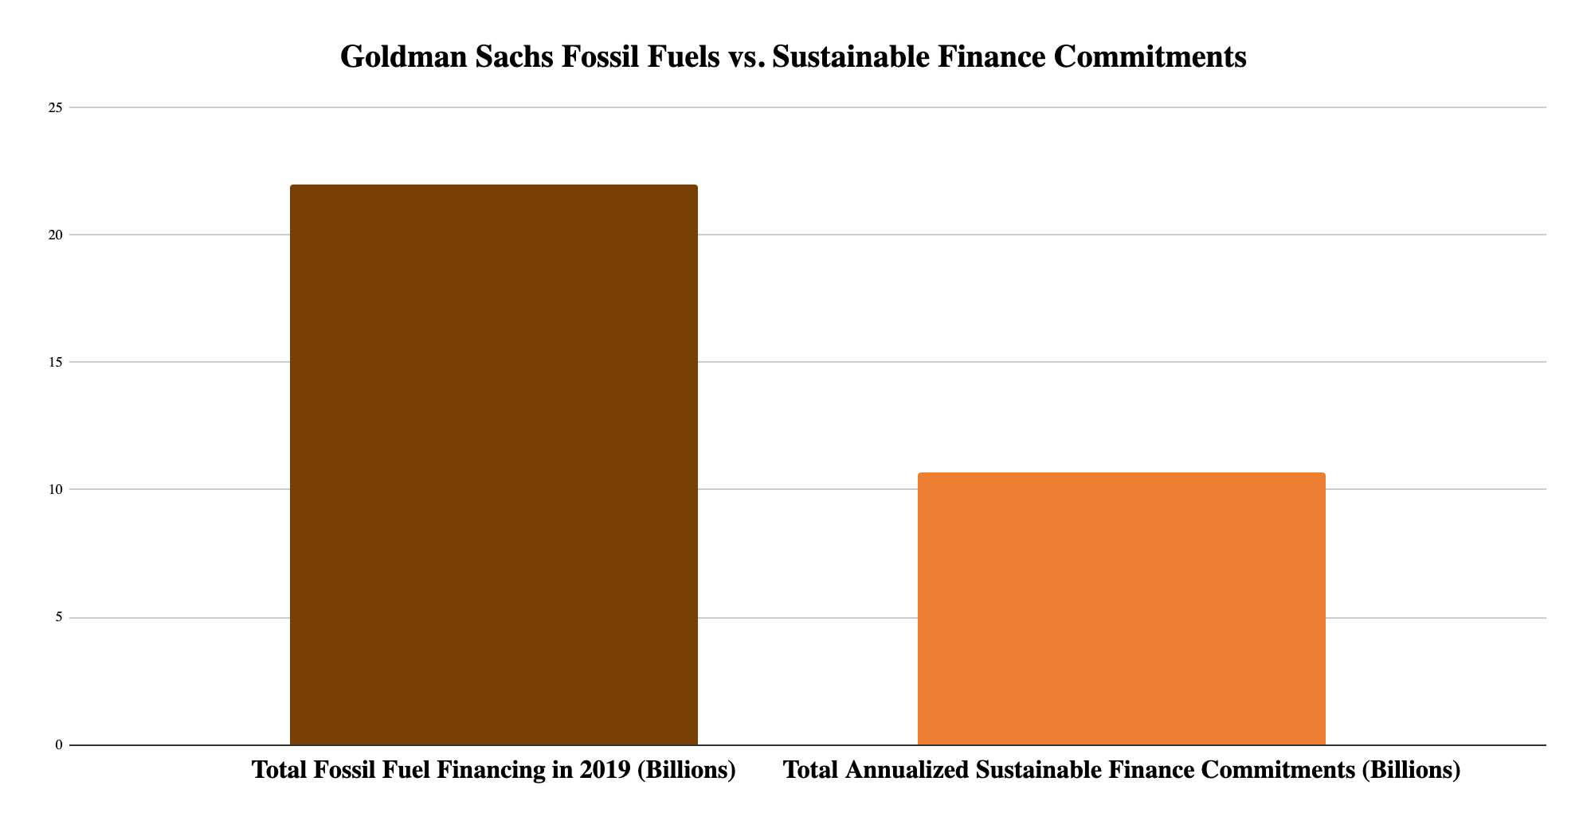
Rainforest Action Network designates policy scores based on a point system that assesses bank policies on ending financing for fossil fuel expansion and phasing out overall fossil fuel financing. Goldman Sachs received only 21.5 out of 200 possible points, demonstrating a very low score. For more detail into the scoring criteria, including for each fossil fuel subsector, visit the Banking on Climate Change 2020 report appendix. See below a fossil fuel policy score comparison of the major private US banks.

Bank | Total Fossil Fuel Policy Score (Out of 200)
Citi | 22
JPMorgan Chase | 19.5
Wells Fargo | 9
Bank of America | 6
Morgan Stanley | 21
Goldman Sachs | 21.5

Fossil Fuel Policies

Goldman Sachs updated its fossil fuels policies in December 2019, as of this update:

Oil & Gas
Goldman Sachs was the first major U.S. bank to establish explicit limits on financing for the oil and gas sector. However, it has not banned the financing of hydraulic fracturing and oil sands.

Coal
Goldman Sachs has ruled out direct finance for new or expanding thermal coal mines and coal-fired power plant projects worldwide. The bank has also committed to a phase-out of financing for significant thermal coal mining companies that do not have a diversification strategy.

Arctic Region
Goldman Sachs released an updated environmental policy framework declining any financing transaction that directly supports new upstream Arctic oil exploration or development, including but not limited to new work in the Alaskan refuge. The policy makes explicit mention of protecting the Arctic National Wildlife Refuge. This made Goldman Sachs the first major U.S. bank to prohibit financing for Arctic oil drilling.

Measure - Disclose - Reduce
In September 2018, Goldman Sachs signed on to the Task Force on Climate Related Financial Disclosures, a set of consistent and coherent principles for voluntary climate-related financial risk disclosures that provide information to investors, lenders, insurers, and other stakeholders.

Recent Low-Carbon Announcements

- Goldman Sachs announced that it will expand its clean energy target to $150 billion in financing and investment by 2025 as part of its updated Environmental Policy Framework.

- In April 2020 Goldman Sachs said it had created a council of traders, sales staff, and others to share expertise on sustainable finance and investing as clients search for ways to achieve climate-change investment commitments, known as the Global Markets Division Sustainable Solutions Council.

- Working with Enel, an Italian-headquartered energy company, Goldman Sachs structured the first sustainability performance bond linked to the United Nations’ Sustainable Development Goals (SDGs) for $1.5 billion in September 2019. Rather than restrict the use of proceeds to specific green projects, the bond ties Enel’s cost of capital to its strategic commitment to make installed capacity 55% renewable by the end of 2021.

Read Goldman Sachs 2019 Sustainability Report here: https://www.goldmansachs.com/what-we-do/sustainable-finance/documents/reports/2019-sustainability-report.pdf

Website | bank-fwd.org
Email | info@bank-fwd.org

