JP Morgan Chase Fact Sheet

Quick Facts & Talking Points

- Ranks #1 on the Dirty Dozen list

- Total Assets 2019
  - $2.7 trillion

- Total Fossil Fuel Financing in 2019
  - $65 B

- Total Fossil Fuel Financing Between 2016-2019
  - $269 B

Between 2016-2019 JPMC financed:
Financing | Fossil Fuel Type | Rank out of Top 35 Fossil Fuel Financiers
$102.3 B | Fossil Fuel Expansion | 1st
$10.3 B | Tar Sands | 3rd
$1.7 B | Arctic oil & gas drilling | 1st
$19.5 B | Offshore oil & gas drilling | 1st
$43.2 B | Fracked oil & gas | 1st
$6.1 B | Liquefied Natural Gas (LNG) | 2nd
$1.8 B | Coal Mining | 6th
$4.2 B | Coal Power Stations | 9th

- Total Annualized Sustainable Finance Commitments
  - $22 B

Leadership

- Under the leadership of Jamie Dimon, CEO and chairman, JPM has contributed more money towards fossil fuel industries than any other bank, leading by 36% over the next largest financier, Wells Fargo, and putting a total of $269 billion into coal, oil and gas firms over the last four years (2016-2019).

- For decades JPM has also been under the leadership of former Exxon Mobil CEO and climate change denier Lee Raymond as lead independent director of the Board. JPM has recently announced that Lee Raymond will step down from his leadership role, primarily due to ongoing pressure from activist groups and state treasurers calling for the need to establish an independent chair and have climate competent board oversight.

Major Fossil Fuel Industry Commitments

- JPM is the first bank to blow past a quarter trillion dollars for fossil fuels since the Paris Agreement in 2015. JPM’s financing of fossil fuel projects represents one of the world’s most significant contributions to climate change and is in direct opposition to the commitment of the Paris Agreement to limit global temperature rise to 1.5°C or at most 2°C, which would require banks to end all new finance of fossil fuel projects and the phase-out of finance for existing projects.

- On April 2, 2020 JPMorgan Chase (along with Citibank) led the underwriting of a USD $1.25 billion bond issuance for TC Energy, the company moving forward with the controversial Keystone XL tar sands oil pipeline. NASA scientist James Hansen explained that draining those tar sands deposits would be “game over” for the climate system.
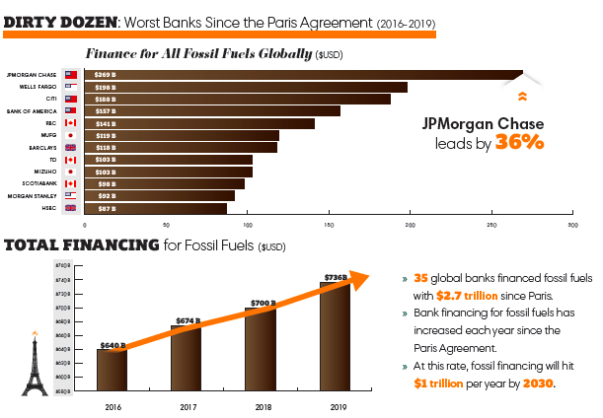
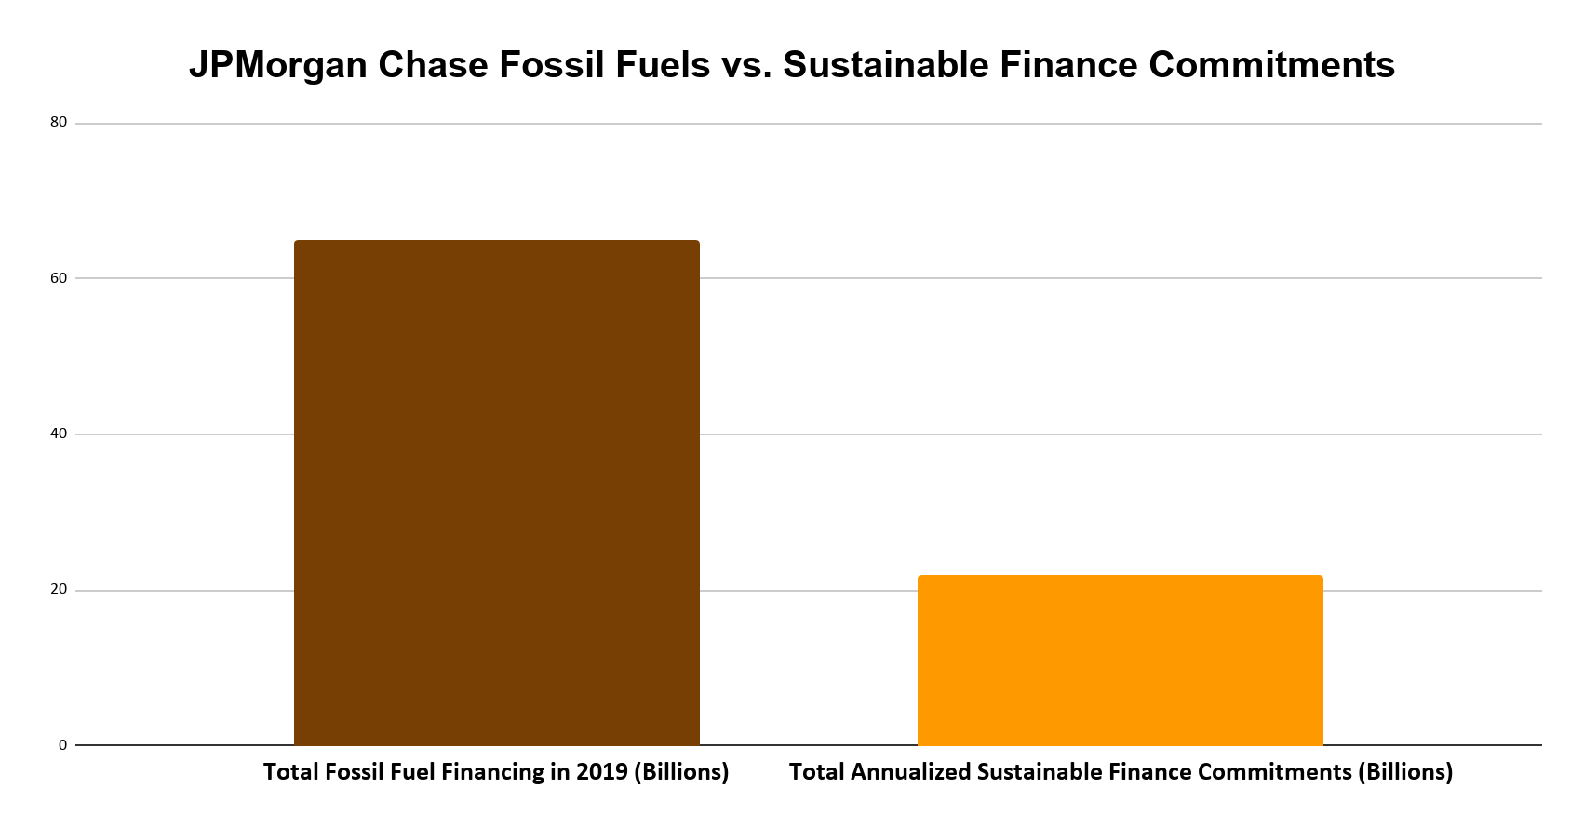Note: JPM committed to facilitating $200 billion in clean financing between 2016 and 2025. This breaks down to an annual average of $22 billion, dwarfing in comparison to their annual fossil fuel financing standing at $65 billion.

Rainforest Action Network designates policy scores based on a point system that assesses bank policies on ending financing for fossil fuel expansion and phasing out overall fossil fuel financing. JPMorgan Chase received only 19.5 out of 200 possible points. For more detail into the scoring criteria, including for each fossil fuel subsector, visit the Banking on Climate Change 2020 report appendix. See below a fossil fuel policy score comparison of the major private US banks as of April 2020.

Bank | Total Fossil Fuel Policy Score (Out of 200)
Citi | 22
JPMorgan Chase | 19.5
Wells Fargo | 9
Bank of America | 6
Morgan Stanley | 21
Goldman Sachs | 21.5

Fossil Fuel Policies

JPMorgan Chase updated its fossil fuels policies in February 2020, as of this update:

Oil & Gas
JPMorgan Chase has not implemented restrictions on oil and gas development such as fracking and oilsands projects.

Coal
JPMorgan Chase has strengthened its restrictions on financing (lending and underwriting) for coal mining and coal power. On coal power, the bank had previously ruled out financing for coal plants only in developed nations, and now prohibits financing for coal plants worldwide. However, its new policy falls short of global best practice in that it only restricts direct financing for new coal plants, and does nothing to restrict financing for the companies behind them.

The policy now prohibits financing for majority coal mining companies, and JPMorgan Chase will zero out its credit exposure to those companies by 2024. However, the coal policy falls short in that it applies only to companies whose primary business is coal mining. This loophole allows the bank to continue financing some of the biggest coal mining companies, many of which are conglomerates that get less than half of their revenue from coal.

Arctic Region
In February 2020, JPM updated its energy policy, banning the financing of new oil and gas development projects in the Arctic and also restricting new thermal coal mines and coal-fired power projects in the Arctic.

However, the policy falls short of explicitly ruling out exploration and does not rule out finance for companies active in the Arctic. The policy also doe not implement restrictions on other oil and gas development, like fracking or oilsands projects elsewhere.

Measure - Disclose - Reduce

In December 2017, JPMC signed on to the Task Force on Climate Related Financial Disclosures, a set of consistent and coherent principles for voluntary climate-related financial risk disclosures that provide information to investors, lenders, insurers, and other stakeholders.

Major Shareholder Actions

- At JPMC’s annual general meeting a number of critical governance and climate-related shareholder proposals were considered. A proposal to align financing to the Paris agreement goals received a reported 49.6% support, and the proposal to elect an independent board chair received 41.96%, its highest support since the 2008 financial crisis.

Recent Low-Carbon Announcements

- In 2017, JPMorgan Chase made two sustainability commitments: facilitate $200 billion in clean financing by 2025 and source renewable energy for 100 percent of its global power needs by 2020. Both of these goals are expected to be reached by the end of 2020.

In 2020 JPMorgan Chase (JPMC) announced the below commitments:

- Most recently, in October 2020, JPMC announced that it will meet its Paris Alignment goal by supporting clients in key sectors in the transition to a low-carbon economy. It will focus on oil and gas, electric power, and automotive manufacturing, setting 2030 targets for its financed emissions in these sectors. JPMC will publish further details informed by recommendations of the TCFD in the spring of 2021. The announcement did not give further detail on the ambition of these financed emissions targets, or the metrics that will be used. That said, it does state it will begin tracking its clients’ carbon intensity, which suggests that the bank may set 2030 targets in terms of its financed emissions intensity. In this announcement JPMC notes that the world must achieve net-zero emissions by 2050 in order to meet the temperature goals of the Paris Agreement, but does not commit to zero out its own financed emissions by that time. In parallel with this decision, JPMC will launch a new Center for Carbon Transition to engage clients on decarbonization.

- JPMC is assembling a new Energy Transition Team to provide strategic and financial advice to corporate clients on M&A transactions that support their carbon optimization objectives.

- JPMC has joined the Climate Leadership Council, a group promoting a bipartisan roadmap for a revenue-neutral carbon tax-and-dividend framework for the United States.

- JPMC is working with Business Roundtable and other trade organizations on market-based policy solutions to address climate change, drive clean energy innovation and protect underserved communities

See more here in JPMorgan Chase’s 2020 Announcement on Sustainability.

See more here in JPMorgan Chase's 2019 Climate Report.

Website | bank-fwd.org
Email | info@bank-fwd.org

The Dirty Dozen is a list of the top 12 private-sector banks that lead in financing the fossil fuel industry. More information can be found here: https://www.ran.org/bankingonclimatechange2020/
JPMorgan Chase Tops Dirty List Of 35 Fossil Fuel-Funding Banks. Forbes 2020.
This is likely a conservative comparison due to differences in how each number is calculated. For instance, JPM has not published details on its methodology for tallying up the $200 billion in total sustainable finance, so to “facilitate” financing could over represent their actual contributions towards a renewable energy project.
Read more about the announcement here: https://www.jpmorganchase.com/corporate/news/pr/jpmorgan-chase-expands-commitment-to-low-carbon-economy-and-clean-energy.htm
See https://www.ran.org/wp-content/uploads/2020/10/Briefer_-Response-to-JPMorgan-Chase%E2%80%99s-Paris-Alignment-Announcement.pdf

