Morgan Stanley Fact Sheet

Quick Facts & Talking Points

- Ranks #11 on the Dirty Dozen list
Morgan Stanley’s fossil fuel financing amounts to only 34% of the amount supplied by the largest fossil fuel-funding bank, JPMorgan Chase.

- Total Assets 2019
$895 B

- Total Fossil Fuel Financing in 2019
$22.8 B

- Total Fossil Fuel Financing between 2016-2019
$92 B

Between 2016-2019, Morgan Stanley financed:
Financing | Fossil Fuel Type | Rank out of Top 35 Fossil Fuel Financiers
$33.5 B | Fossil Fuel Expansion | 12th
$637 M | Tar Sands | 17th
$540 M | Arctic oil & gas drilling | 21st
$10.4 B | Offshore oil & gas drilling | 6th
$9.3 B | Fracked oil & gas | 13th
$6.6 B | Liquefied Natural Gas (LNG) | 1st
$785 M | Coal Mining | 10th
$2.5 B | Coal Power Stations | 18th

- Total Annualized Sustainable Finance Commitments
$19.2 B

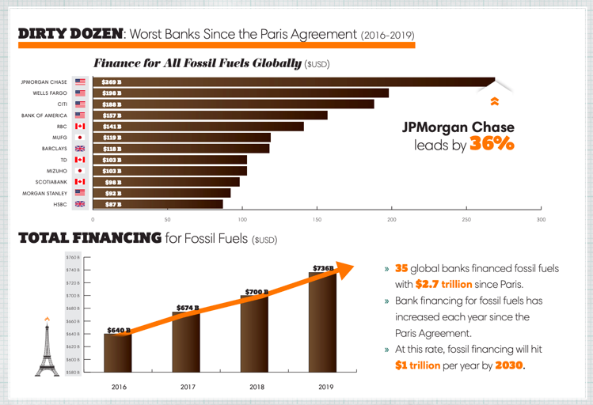

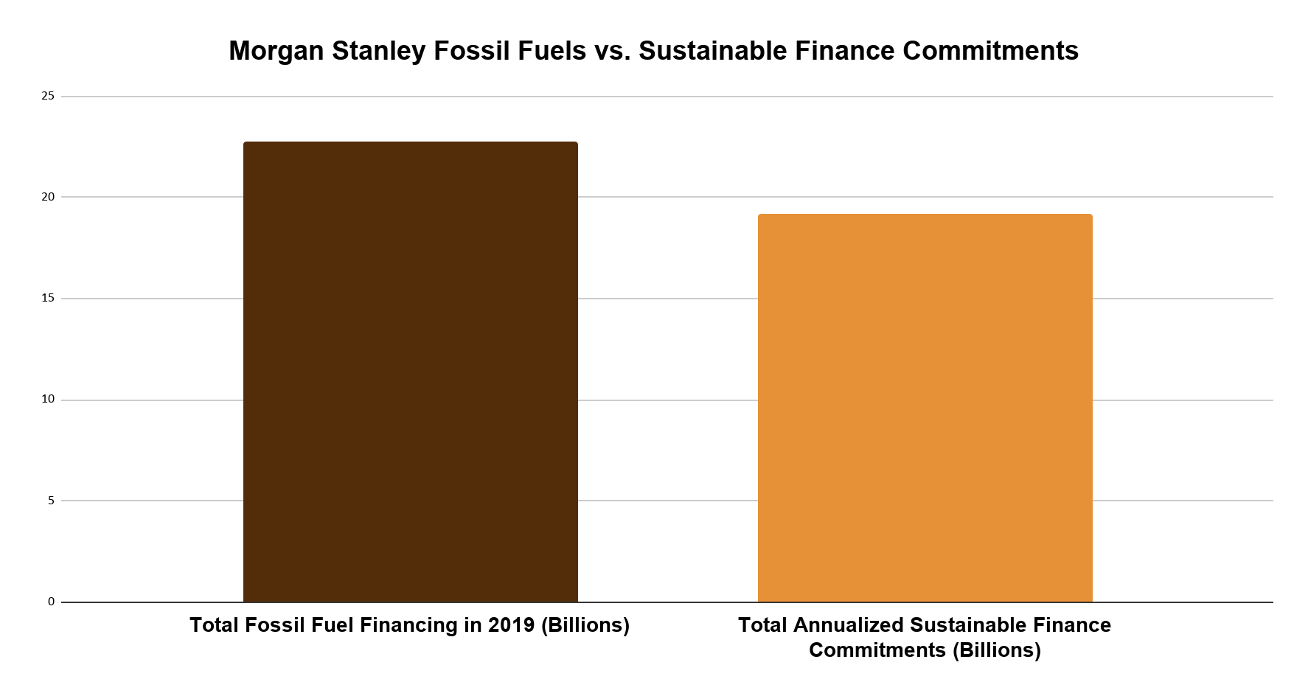
Rainforest Action Network (RAN) designates policy scores based on a point system that assesses bank policies on ending financing for fossil fuel expansion and phasing out overall fossil fuel financing. Morgan Stanley received only 21 out of 200 possible points, demonstrating a very low score. For more detail into the scoring criteria, including for each fossil fuel subsector, visit the Banking on Climate Change 2020 report appendix and RAN’s latest press release. See below a fossil fuel policy score comparison of the major private US banks as of April 2020.

Bank | Total Fossil Fuel Policy Score (Out of 200)
Citi | 22
JPMorgan Chase | 19.5
Wells Fargo | 9
Bank of America | 6
Morgan Stanley | 21
Goldman Sachs | 21.5

Fossil Fuel Policies
Morgan Stanley updated its energy policy in March, 2020. As of this update:

Oil
Morgan Stanley still finances deepwater drilling, tar sands, and fracking, for a total of $6.4 billion in 2019 according to the Banking on Climate Change report.

Coal
The policy update also rules out direct financing of new thermal coal mines and coal-fired power plants, as well as a commitment to phase out financing of thermal coal companies.

Arctic Region
Morgan Stanley has committed to not financing oil & gas exploration in the Arctic, including Alaska’s Arctic National Wildlife Refuge.

Measure - Disclose - Reduce

In July 2020 Morgan Stanley committed to the PCAF Standards, agreeing to disclose the greenhouse gas emissions associated with their portfolio of loans and investments. This decision made them the first major U.S. bank to do so.

In June 2017 Morgan Stanley signed on to the Task Force on Climate Related Financial Disclosures, a set of consistent and coherent principles for voluntary climate-related financial risk disclosures that provide information to investors, lenders, insurers, and other stakeholders.

Most Recent Low-Carbon Commitments

As of 2018, Morgan Stanley committed to providing $250 billion in low-carbon financing between 2018 - 2030 and to become carbon neutral by 2022, with an aim to source 100 percent of global operational energy needs from renewable energy and to offset any remaining emissions.

As of 2019, Morgan Stanley has reached $80 billion of its $250 billion low-carbon financing goal.

Contributing to this commitment are the Firm’s activities in clean-tech and renewable energy financing, sustainable bonds, and other transactions that enable low-carbon solutions.

“This announcement reflects Morgan Stanley’s continued commitment to enabling private sector capital to find attractive opportunities in the growing market for low-carbon solutions,” said Audrey Choi, Morgan Stanley’s Chief Sustainability Officer and Chief Marketing Officer.

As of September 2020, Morgan Stanley announced a new commitment to reach net-zero financed emissions by 2050, though the announcement did not include details on the bank’s plan to get there.

See more here in Morgan Stanley’s 2019 Sustainability Report.

See more here in Morgan Stanley’s Environmental and Social Policy Statement.

Website | bank-fwd.org
Email | info@bank-fwd.org

Rainforest Action Network, Banking on Climate Change- Fossil Fuel Finance Report 2020.
World Resources Institute, GREEN TARGETS: A Tool To Compare Private Sector Banks’ Sustainable Finance Commitments, July 2019.

