Wells Fargo Fact Sheet

Quick Facts & Talking Points

- Total Assets 2019
  - $1.9 trillion

- Total Fossil Fuel Financing in 2019
  - $45.2 billion

- Total Fossil Fuel Financing Between 2016-2019
  - $198 billion

Between 2016-2019 Wells Fargo financed:
Financing | Fossil Fuel Type | Rank out of Top 35 Fossil Fuel Financiers
$52.18 B | Fossil Fuel Expansion | 4th
$1.2 B | Tar Sands | 13th
$383 M | Arctic oil & gas drilling | 24th
$1.5 B | Offshore oil & gas drilling | 25th
$30.8 B | Fracked oil & gas | 2nd
$323 M | Liquefied Natural Gas (LNG) | 28th
- | Coal Mining | -
$3.6 B | Coal Power Stations | 12th

- Total Annualized Sustainable Finance Commitments
  - $15.4 billion

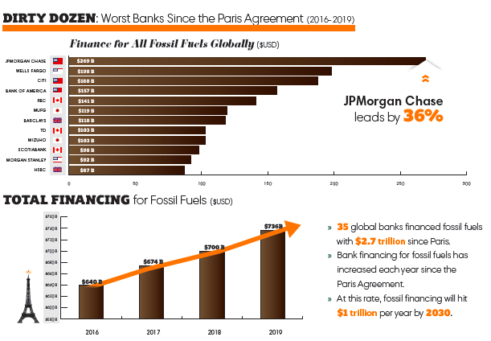

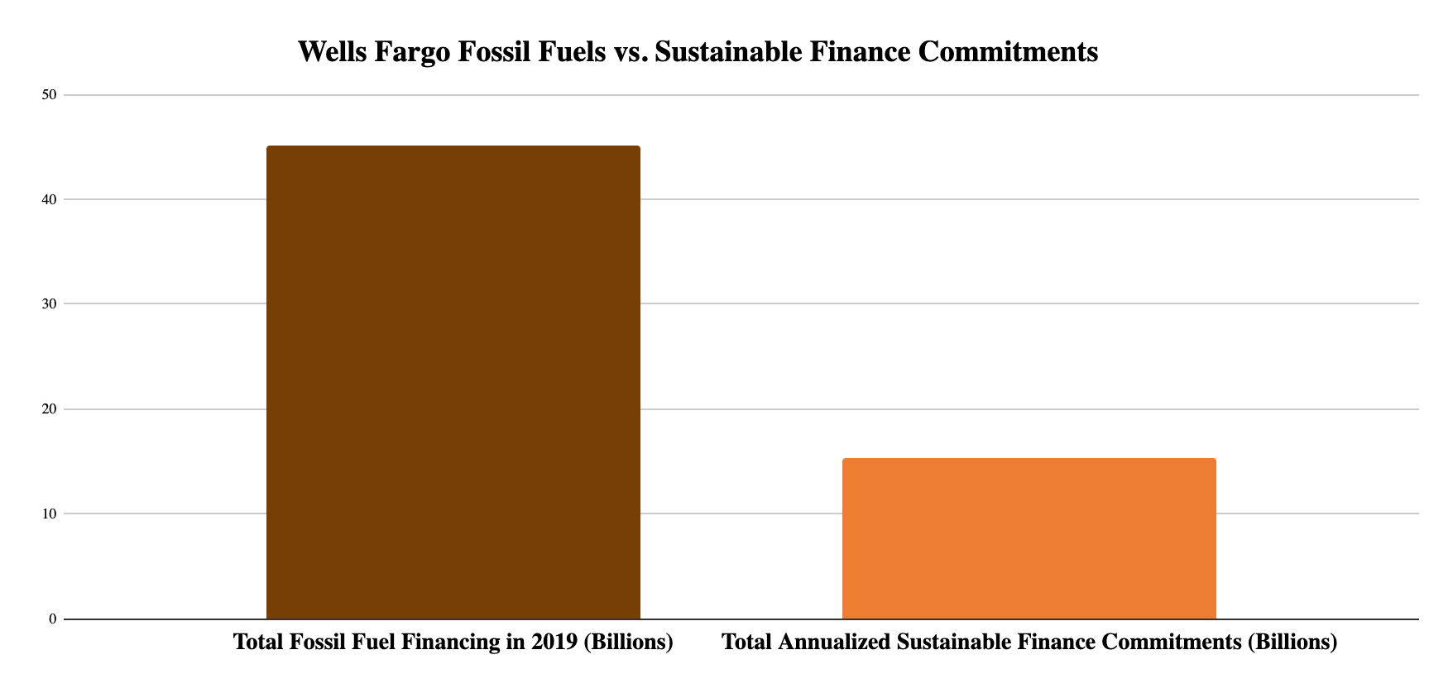

Rainforest Action Network designates policy scores based on a point system that assesses bank policies on ending financing for fossil fuel expansion and phasing out overall fossil fuel financing. Wells Fargo received only 9 out of 200 possible points, demonstrating a very low score. For more detail into the scoring criteria, including for each fossil fuel subsector, visit the Banking on Climate Change 2020 report appendix. See below a fossil fuel policy score comparison of the major private US banks.

Bank | Total Fossil Fuel Policy Score (Out of 200)
Citi | 22
JPMorgan Chase | 19.5
Wells Fargo | 9
Bank of America | 6
Morgan Stanley | 21
Goldman Sachs | 21.5

Fossil Fuel Policies

Wells Fargo updated its fossil fuels policies in August 2020, as of this update:

Oil & Natural Gas
Wells Fargo has no explicitly prohibitive oil & gas policies. For companies that operate in the oil and gas industries, Wells Fargo applies three additional phases of due diligence to understand the environmental and social risk and potential mitigation measures. Each transaction receives an environmental and social risk rating – low, moderate, high, or critical. Wells Fargo will escalate any transaction internally rated as high or critical for senior leadership approval.

Coal
Wells Fargo does not directly finance mountaintop removal (MTR) coal mining projects, nor extend credit or facilitate capital-markets transactions to coal producers engaged primarily in MTR mining, and will continue to limit and reduce credit exposure to the coal mining industry.

Arctic Region
In March 2020, Wells Fargo announced that it will not invest in Arctic National Wildlife Refuge on Alaska's North Slope. However, the policy applies only to project finance in the region, and the bank will continue to have ongoing business relationships with numerous companies involved in the oil and gas industry in the Alaska Arctic region and expect to continue those relationships long into the future.

Measure - Disclose - Reduce
In November 2019, Wells Fargo signed on to the Task Force on Climate Related Financial Disclosures, a set of consistent and coherent principles for voluntary climate-related financial risk disclosures that provide information to investors, lenders, insurers, and other stakeholders.

Wells Fargo uses an Environmental and Social Risk Management Framework (ESRM) to build on due diligence requirements and help the bank to identify, evaluate, and manage the environmental and social risks associated with lending and investments.

Recent Low-Carbon Announcements

- In 2018 Wells Fargo committed to providing $200 billion in financing to sustainable businesses and projects between 2018 and 2030, with more than 50 percent focused on clean technology and renewable energy transactions that directly support the transition to a low-carbon economy.

- In 2019, Wells Fargo established a cross-functional Climate Change Working Group, which leverages internal expertise, leading climate science and assumptions, and external resources to enhance understanding of the implications of climate change on business and to make recommendations to company leaders with regard to policies and procedures that advance climate-risk management across the enterprise in a coordinated and strategic manner.

- Wells Fargo has an Innovation Incubator, which is a $30 million philanthropic program with the U.S. Department of Energy’s National Renewable Energy Laboratory that speeds the path to market for promising clean technologies and entrepreneurs focused on energy efficiency and sustainability.

- Nate Hurst joined the company on June 1, 2020 to oversee a newly combined organization that includes Corporate Responsibility, Philanthropy, Community Relations, and Sustainability. Under Hurst’s leadership, the company plans to further integrate sustainability and corporate responsibility into all aspects of its business.

- Wells Fargo’s sustainable finance reporting methodology is publicly available and provides significant detail as to how it defines sustainable finance and accounts for progress with respect to commitments.

- Wells Fargo is a signatory to the UN Principles for Responsible Investment.

Read more here about Wells Fargo’s sustainability commitments: https://www.wellsfargo.com/about/corporate-responsibility/environment/

Read the Wells Fargo Climate Change Issue Brief: https://www08.wellsfargomedia.com/assets/pdf/about/corporate-responsibility/climate-change-issue-brief.pdf

Website | bank-fwd.org
Email | info@bank-fwd.org

